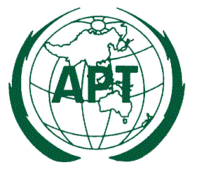

DRAFT APT RECOMMENDATION ADOPTION FORM

To adopt a Draft APT Recommendation you are requested to indicate “YES” (in case you support) or “NO” (in case you don’t support) in the “Adoption” column of the table. Please leave blank in case you don’t have any comment. In case if you indicate “NO” for Draft Recommendation please indicate reason in the “Remarks” column.

Please return the completed form on or before 13 July 2018 to the APT Secretariat by email: aptastap@apt.int or by fax +66 2 573 7479.

.
Table 1: Adoption of the Draft APT Recommendation

Title of Draft APT Recommendation | Source Document | Adoption  (YES/NO) | Remarks
Draft APT Recommendation on “Standard Specification of Information and Communication System using Vehicle during Disaster” | ASTAP-30/OUT-22

The undersign authorizes the Asia-Pacific Telecommunity to count the adoption of the Draft APT Recommendations in the name of my Administration for which my Administration has indicated in the table above.

Signature: _ _ _ _ _ _ _ _ _ _ _ _ _ _ _ _ _ _ _ _ _ _

Name: _ _ _ _ _ _ _ _ _ _ _ _ _ _ _ _ _ _ _ _ _ _

Designation: _ _ _ _ _ _ _ _ _ _ _ _ _ _ _ _ _ _ _ _ _ _

Administration: _ _ _ _ _ _ _ _ _ _ _ _ _ _ _ _ _ _ _ _ _ _

Country: _ _ _ _ _ _ _ _ _ _ _ _ _ _ _ _ _ _ _ _ _ _

E-mail: _ _ _ _ _ _ _ _ _ _ _ _ _ _ _ _ _ _ _ _ _ _

